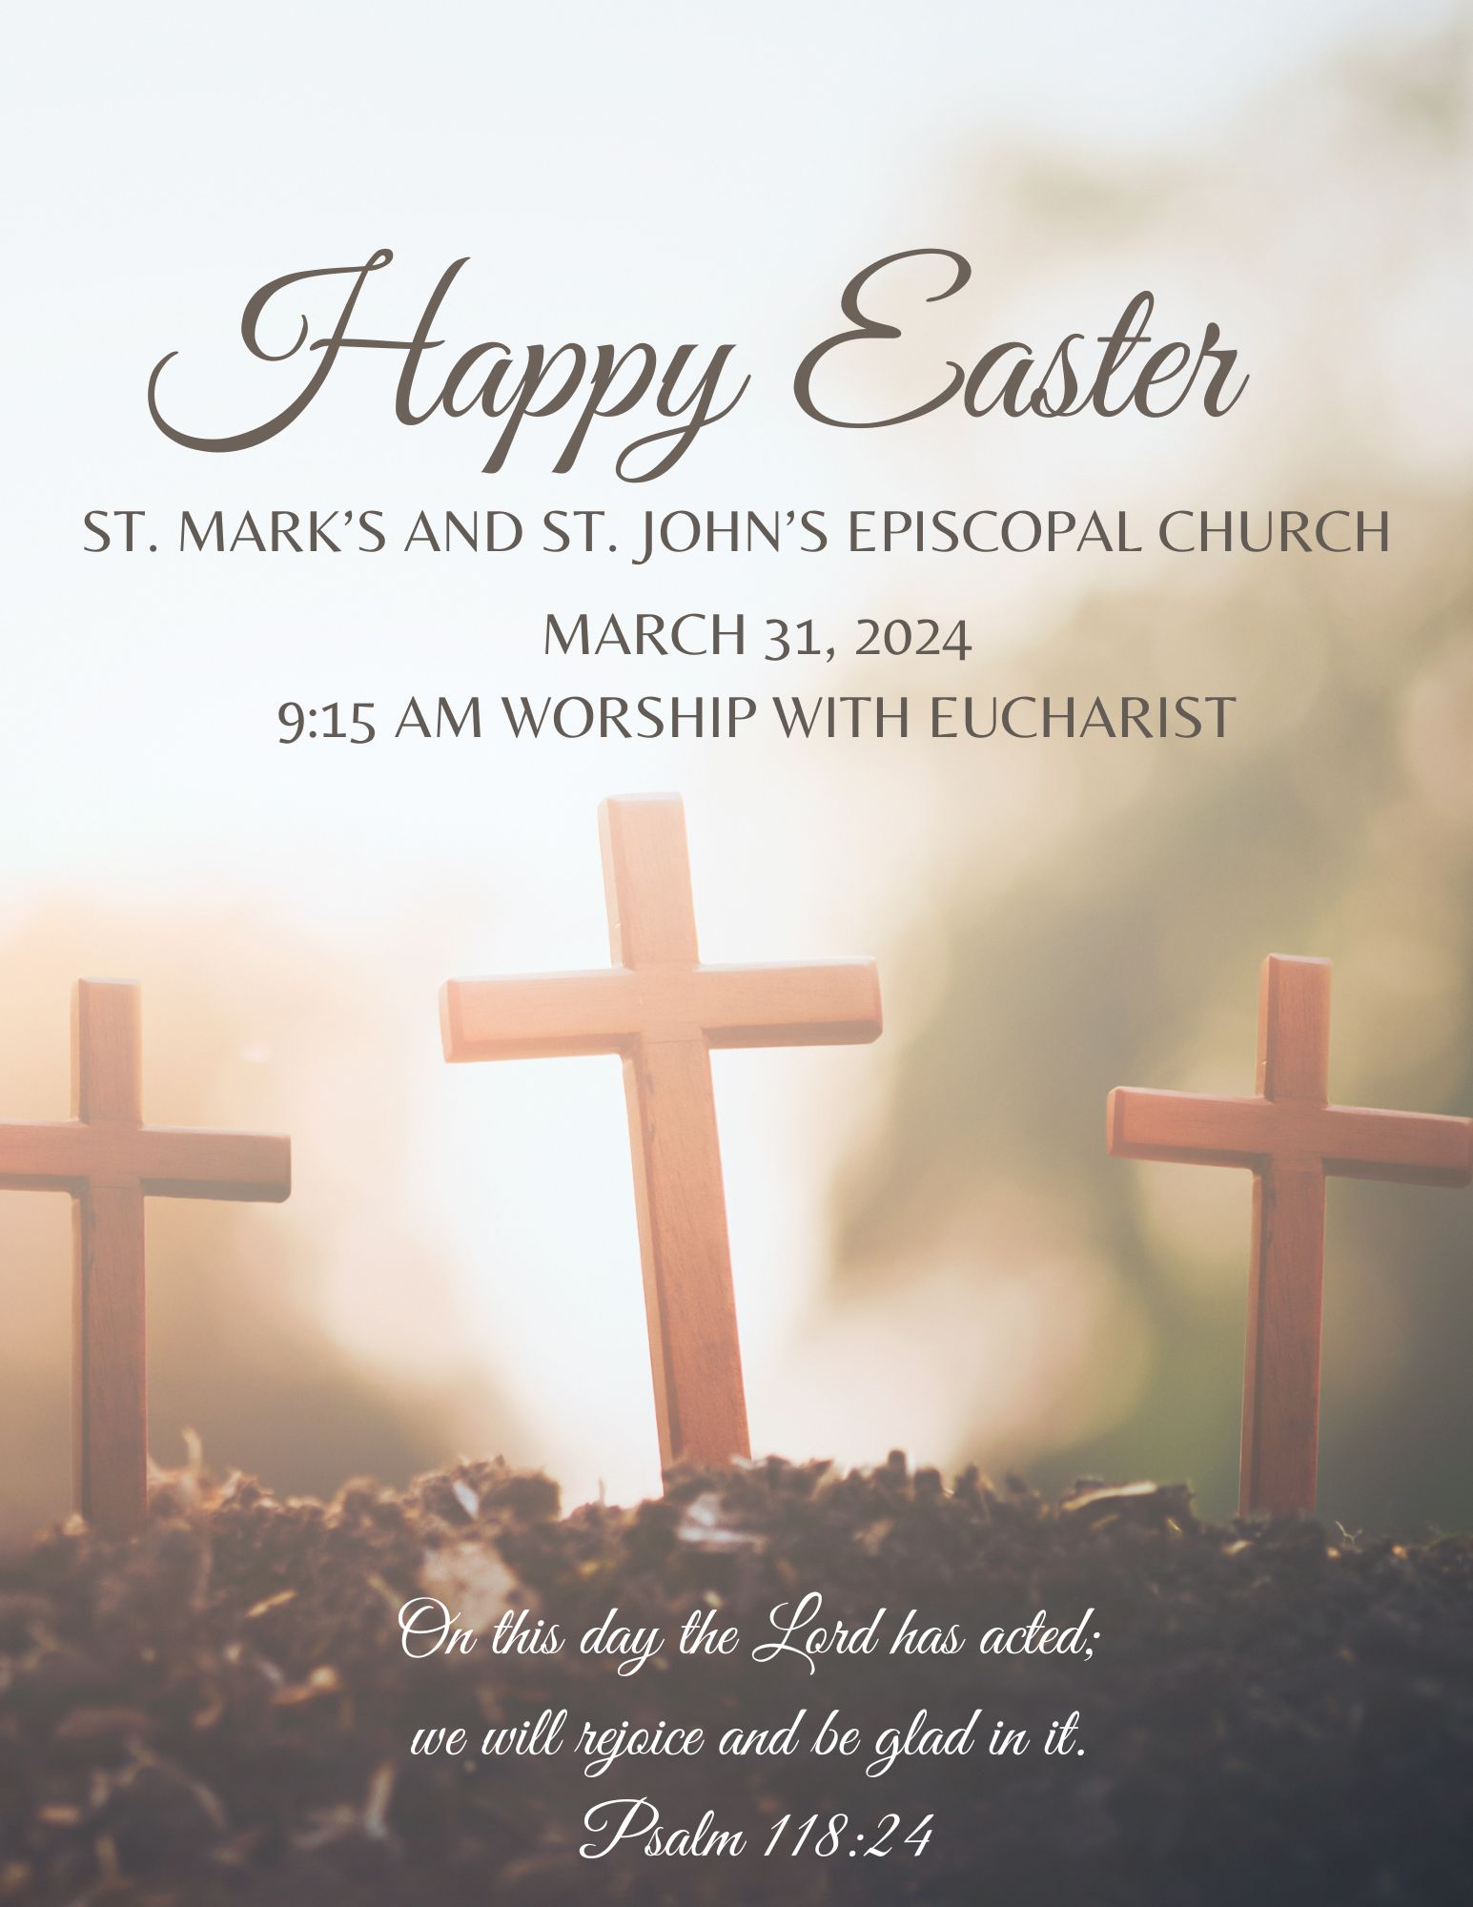

Welcome to St. Mark’s and St. John’s!

Name tags are available. We’d love to
make one for you if you do not have one already.

Help yourself to coffee in the “cafe,” and feel free
to bring it to your pew. We’re casual.

We invite children to make themselves at home at our children’s table, where there are weekly
activity bulletins and crayons.

Our live YouTube broadcast begins at 9:15 am. The link to our YouTube channel is available on our website,
stmarksandstjohns.org.

We do not pass an offering plate during the service.
If you would like to make a financial gift, you can place
it in the plate (by the sign-in binder) or contribute online.
PRELUDE

“Morning Has Broken” Gaelic Melody
“Sing to the Mountains” Robert J. Dufford

OPENING MUSIC “Jesus Christ Is Risen Today”
OPENING ACCLAMATION

Alleluia! Christ has risen.
Christ has risen indeed. Alleluia!

COLLECT FOR PURITY

Celebrant: Almighty God, to you all hearts are open, all desires known, and from you no secrets are hid: Cleanse the thoughts of our hearts by the inspiration of your Holy Spirit, that we may perfectly love you, and worthily magnify your holy Name; through Christ our Lord. Amen.

Kyrie eleison
Christe eleison.
Kyrie eleison.

Celebrant: Almighty God, who through your only-begotten Son Jesus Christ overcame death and opened to us the gate of everlasting life: Grant that we, who celebrate with joy the day of the Lord's resurrection, may be raised from the death of sin by your life-giving Spirit; through Jesus Christ our Lord, who lives and reigns with you and the Holy Spirit, one God, now and forever. Amen.

THE FIRST LESSON Acts 10:34-43

Peter began to speak to Cornelius and the other Gentiles: "I truly understand that God shows no partiality, but in every nation anyone who fears him and does what is right is acceptable to him. You know the message he sent to the people of Israel, preaching peace by Jesus Christ--he is Lord of all. That message spread throughout Judea, beginning in Galilee after the baptism that John announced: how God anointed Jesus of Nazareth with the Holy Spirit and with power; how he went about doing good and healing all who were oppressed by the devil, for God was with him. We are witnesses to all that he did both in Judea and in Jerusalem. They put him to death by hanging him on a tree; but God raised him on the third day and allowed him to appear, not to all the people but to us who were chosen by God as witnesses, and who ate and drank with him after he rose from the dead. He commanded us to preach to the people and to testify that he is the one ordained by God as judge of the living and the dead. All the prophets testify about him that everyone who believes in him receives forgiveness of sins through his name."

Lector: Hear what the Spirit is saying.
People: Thanks be to God.
PSALM 118: 1-2, 14-24

Give thanks to the Lord, for he is good; *
his mercy endures for ever.

Let Israel now proclaim, *
"His mercy endures for ever."

The Lord is my strength and my song, *
and he has become my salvation.

There is a sound of exultation and victory *
in the tents of the righteous:

"The right hand of the Lord has triumphed! *
the right hand of the Lord is exalted!
the right hand of the Lord has triumphed!"

I shall not die, but live, *
and declare the works of the Lord.

The Lord has punished me sorely, *
but he did not hand me over to death.

Open for me the gates of righteousness; *
I will enter them;
I will offer thanks to the Lord.

"This is the gate of the Lord; *
he who is righteous may enter."

I will give thanks to you, for you answered me *
and have become my salvation.

The same stone which the builders rejected *
has become the chief cornerstone.

This is the Lord's doing, *
and it is marvelous in our eyes.

On this day the Lord has acted; *
we will rejoice and be glad in it.

THE SECOND LESSON 1 Corinthians 15:1-11
I would remind you, brothers and sisters, of the good news that I proclaimed to you, which you in turn received, in which also you stand, through which also you are being saved, if you hold firmly to the message that I proclaimed to you--unless you have come to believe in vain.

For I handed on to you as of first importance what I in turn had received: that Christ died for our sins in accordance with the scriptures, and that he was buried, and that he was raised on the third day in accordance with the scriptures, and that he appeared to Cephas, then to the twelve. Then he appeared to more than five hundred brothers and sisters at one time, most of whom are still alive, though some have died. Then he appeared to James, then to all the apostles. Last of all, as to one untimely born, he appeared also to me. For I am the least of the apostles, unfit to be called an apostle, because I persecuted the church of God. But by the grace of God I am what I am, and his grace toward me has not been in vain. On the contrary, I worked harder than any of them--though it was not I, but the grace of God that is with me. Whether then it was I or they, so we proclaim and so you have come to believe.

Lector: Hear what the Spirit is saying.
People: Thanks be to God.

GOSPEL ACCLAMATION “Christ is Alive”

GOSPEL John 20:1-18
The Holy Gospel of our Lord Jesus Christ according to John.
Glory to you, Lord Christ.

On the first day of the week, at early dawn, the women who had come with Jesus from Galilee came to the tomb, taking the spices that they had prepared. They found the stone rolled away from the tomb, but when they went in, they did not find the body. While they were perplexed about this, suddenly two men in dazzling clothes stood beside them. The women were terrified and bowed their faces to the ground, but the men said to them, "Why do you look for the living among the dead? He is not here, but has risen. Remember how he told you, while he was still in Galilee, that the Son of Man must be handed over to sinners, and be crucified, and on the third day rise again." Then they remembered his words, and returning from the tomb, they told all this to the eleven and to all the rest. Now it was Mary Magdalene, Joanna, Mary the mother of James, and the other women with them who told this to the apostles. But these words seemed to them an idle tale, and they did not believe them. But Peter got up and ran to the tomb; stooping and looking in, he saw the linen cloths by themselves; then he went home, amazed at what had happened.
Celebrant: The Gospel of our Lord.
People: Praise to you, Lord Christ.

EASTER SERMON The Rev’d Cindy Rasmussen, Ph.D.

AFFIRMATION OF FAITH Community of Iona Abbey

We believe in God
in whom is power and compassion.
We believe in the Creator who gave birth to the universe,
set solar systems dancing into space,
shaped molecules and mountains,
and conceived beauty beyond our imagining.
God’s power topples tyrants,
and brings down walls of separation;
God’s love embodies the tenderness of a mother and father,
encouraging and caring for each of us.

We believe in Jesus, born in poverty in an occupied land;
a human being, vulnerable to hunger, thirst, persecution and grief.
He understood the power of love and confronted the powers of evil, spoke truth with courage and clarity,
forgave his enemies and changed lives.
In his living, dying and rising again he showed
love strong enough to save the world.

We believe in the Holy Spirit
who sustains, comforts and empowers us,
opens the scriptures, opens our minds,
and illuminates earth’s darkness.
Amen.

CHILDREN’S MOMENT Maria Hartz

SPECIAL MUSIC FOR PRAYER AND MEDITATION Please be seated You’re invited to light a candle at our prayer table and write your prayer intentions on one of the Prayer Boards during the music.

PRAYERS OF GRATITUDE

We give you thanks and praise, O God of creation, for the grandeur of all that you have made, saying
Thank you, God.

For the healing waters of creation, which bring pleasure and health, purity and life,
Thank you, God.

For the richness of soil that covers so much of our earth that we may know your presence more fully as we work to remediate the soil in city lots as we nurture the land.
Thank you, God.

For the soaring birds of the air, the crawling creatures on the earth, the gliding fishes in the seas, for all creatures great and small with whom we share this precious web of life,
Thank you, God.

For your life giving spirit and your promise to always be with us. We pray for those who are experiencing pain, sadness, distress, or uncertainty that you may provide relief to their suffering. We pray especially today for…
Thank you, God.

Celebrant: O Lord our God, accept the fervent prayers of your people; in the multitude of your mercies, look with compassion upon us and all who turn to you for help; for you are gracious, O lover of souls, and to you we give glory, Creator, Redeemer, and Holy Spirit, now and forever. Amen.

PASSING OF THE PEACE

Celebrant: The peace of the Lord be with you always.
People: And also with you.

OFFERTORY SENTENCE

Celebrant: I appeal to you, brothers and sisters in Christ, by the mercies
of God, to present yourselves as a living sacrifice, holy and acceptable
to God, which is your spiritual worship. Romans 12:1

We do not pass offering plates at SMSJ. If you would like to make a financial gift to
the mission and ministry of the church there is an offering plate by the sign-in
book in the back or you can give electronically by going to stmarksandstjohns.org

Eucharistic Ministers bring the elements and offering forward

DOXOLOGY “Let all Things Now Living”

MUSIC “Crowded Table”
Brandi Carlile, Natalie Hemby, and Lori McKenna
Text adapted for worship

Refrain
I want a church with a crowded table
And a place at the altar for everyone
Let us take on the world while we're fed and able
And bring us back together when the day is done.
If we want a garden we're gonna have to sow the seed
Plant a little happiness - let the roots run deep
If it's love that we give - then it's love that we reap
If we want a garden we're gonna have to sow the seed (+ Refrain)

THE GREAT THANKSGIVING

The Lord be with you
and also with you.

Lift up your hearts.
We lift them up to the Lord.

Let us give thanks to the Lord our God.
It is right to give God thanks and praise.
It is indeed right that we should praise you, God of love, our source and our fulfillment, for you create all things, and in you we live and move and have our being. Your wonder is manifest in land and sea and sky. When the times had at last grown full and the earth had ripened in abundance, you made us in your image for yourself.
And even though we turn from you, again and again you call us to yourself, and in every age, promise liberation. As a parent tenderly gathers her children, you embraced a people as your own to rear them in your way of compassionate love. From your own being you sent Jesus among us, incarnate of the Holy Spirit and born of Mary our sister and Joseph our brother.
Jesus revealed your care for all you have made. You send forth your Holy Spirit ever giving birth and rebirth to your church.
Now we join hands around your table, and with all creation we sing your hymn of unending love,

To you indeed be glory, almighty God, on the night before he died, your Son, Jesus Christ, took bread; when he had given you thanks, he broke it, gave it to his disciples, and said:
Take, eat, this is my body which is given for you; do this to remember me.
After supper, he took the cup; when he had given you thanks, he gave it to them and said:
This cup is the new covenant in my blood poured out for you; do this as often as you drink it to remember me.
And so, in this sacrament, we celebrate and proclaim the mystery of our faith.
Christ has died,
Christ is risen,
Christ will come in glory.

Therefore, loving God, recalling now Christ’s life, death, and resurrection, we ask you to send your Holy Spirit upon us and this celebration, that we may be fed with the body and blood of your Son and be filled with your life and goodness. Strengthen us to do your work, and to be your resurrected body offering hope to the world.
Unite us in Christ and give us your peace. Through your Holy Spirit, burning as a flame, gentle as a dove, may we who receive these gifts live lives of justice, love, and prayer, and be a voice for those who have not been heard. In union with your whole church we worship you, O God, in songs of everlasting praise.
Blessing, honor and glory be yours, here and everywhere,
now and forever. Amen.

As our Savior Christ has taught us, we are bold to sing,

THE BREAKING OF THE BREAD

All who thirst, all who hunger, come and be filled with God’s goodness.

WELCOME TO THE TABLE
ALL are welcome to receive communion. Please be seated.
An usher will direct you to the center aisle. Gluten-free wafers are available. We offer both the common cup/ individual glasses (grape juice is also available). We ask that you refrain from intinction (dipping your wafer into the common cup). If you would like to receive a blessing instead of communion just let Pastor Cindy know.

COMMUNION MUSIC “The Strife is O’er”
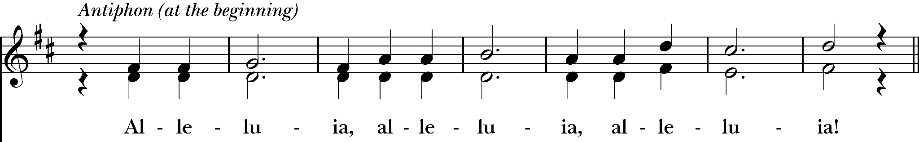
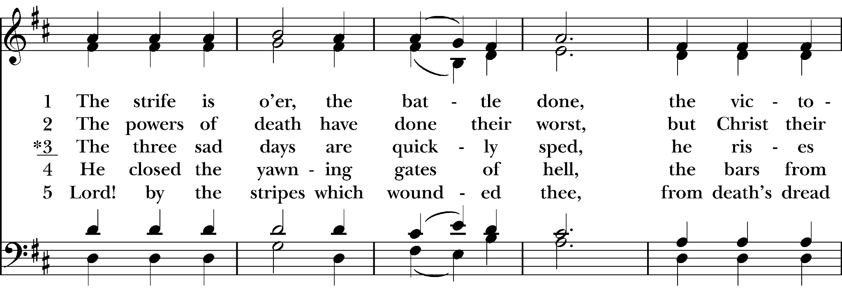
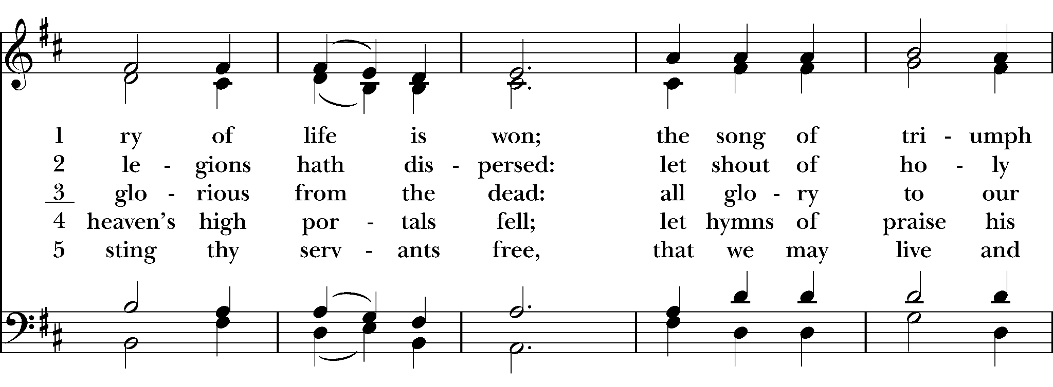
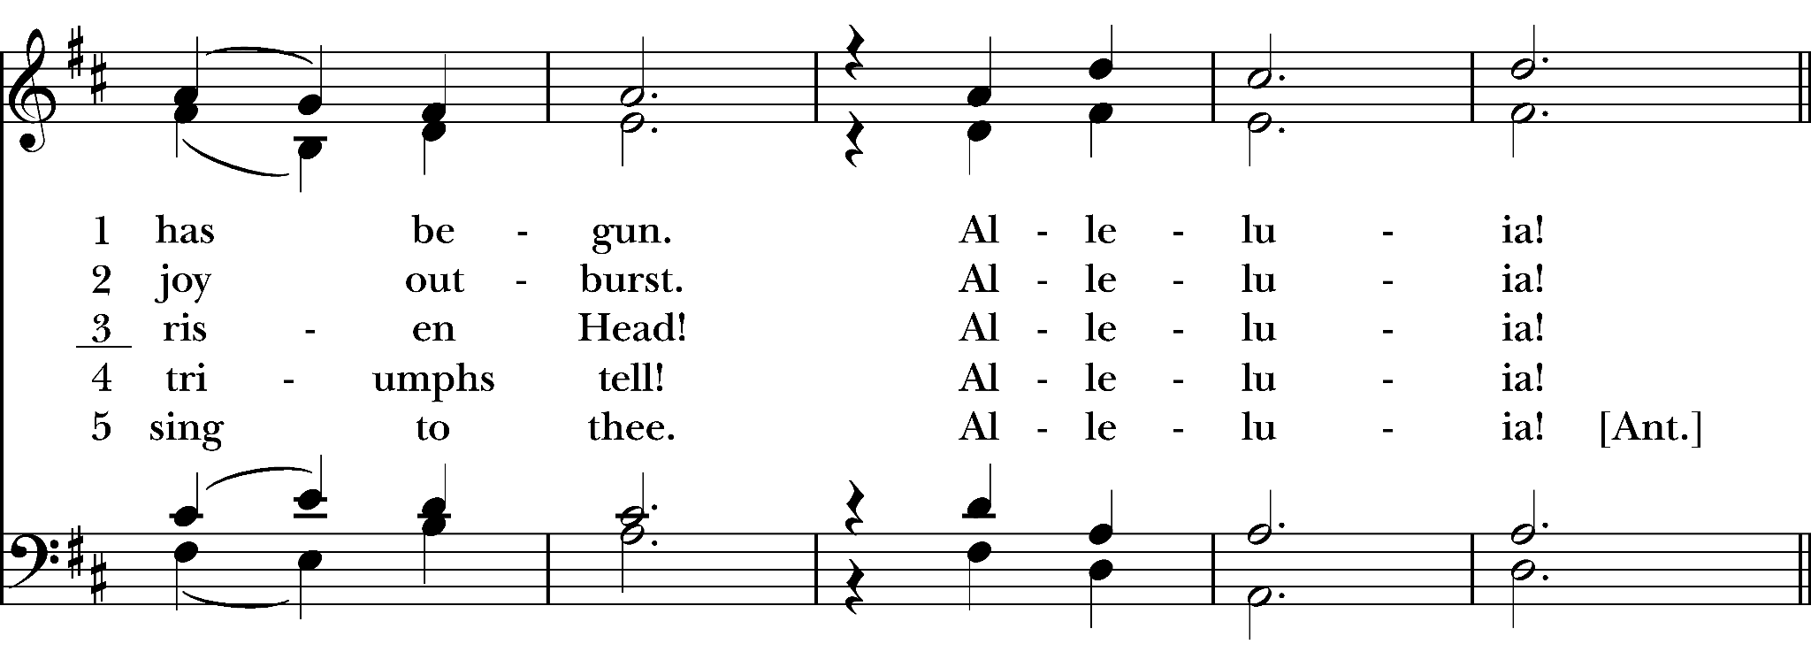
“Lord of the Dance”
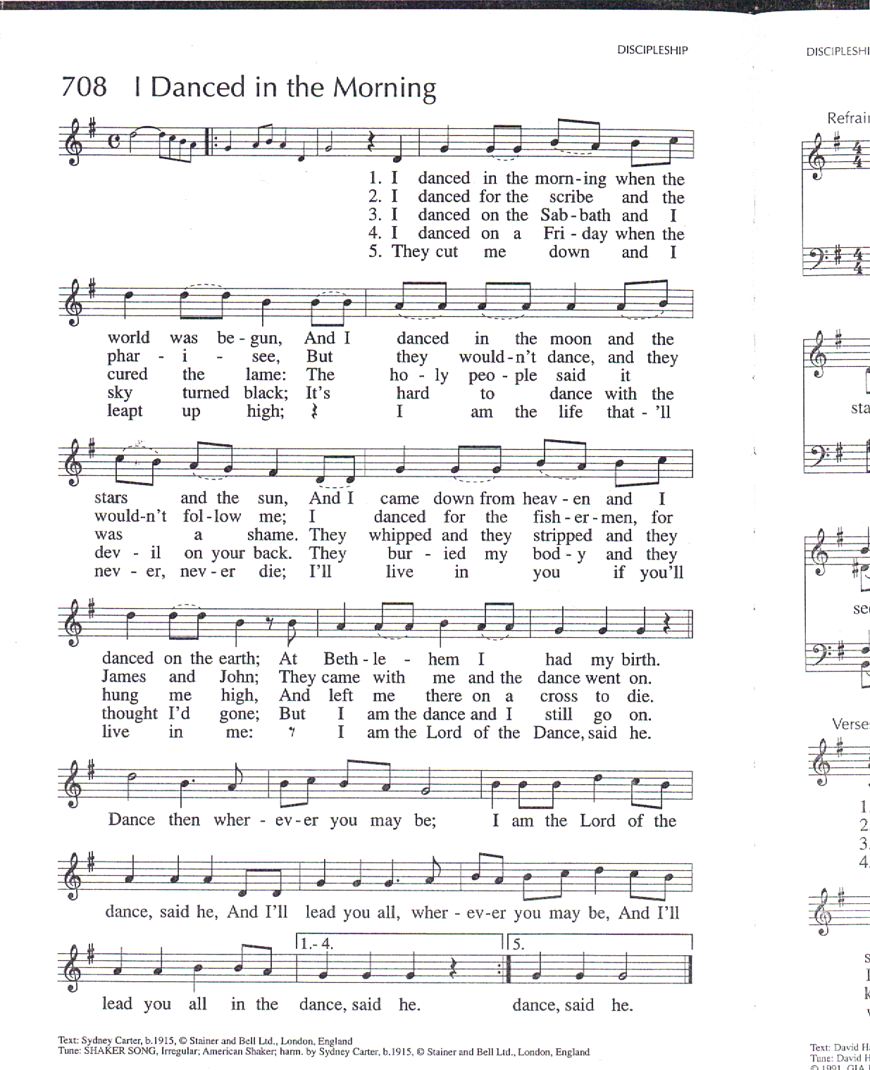
POSTCOMMUNION PRAYER

Life-giving God, in the mystery of Christ’s resurrection, you send light to conquer darkness, water to give new life, and the bread of life to nourish your people. Send us forth as witnesses to your Son’s resurrection that we may show your glory to all the world; through Jesus Christ our Lord. Amen.

FINAL BLESSING

God has given us new birth into a living hope through the resurrection of Jesus Christ. The blessing of God Almighty, the Holy Trinity, bless you and raise you to new life, both now and forever. Amen.

DISMISSAL

Alleluia. Alleluia. Go in peace to love and serve the Lord.
Thanks be to God. Alleluia. Alleluia.

Join us for our Annual EASTER EGG HUNT following the service.

The Easter Flowers are given to the glory of God
in Loving Memory of those who have died

Robert & Patricia Censak
Dorothy Barnes
Hazel Champion
John & Alice Travers
Joseph Gilfoy
Charles & Phyllis Graham
William & Gertrude Traugott
Bob & Geraldine Casper
Dorothy Hurlburt
Roger Colegrove
Ernie Drum
Thomas Bullinger
William and Nellie Burton
Frank, Rose, & Jeff Caruso
Gary, Violet and Terry Estey
Forszt-Kaczynski-Rasmussen-Drum Families
Pat and Adelaide Flood, Joe and Michele Laskey
Sandy Robinson
William, Doris, and Jeff Roosa
Yvonne and Harold Heath
Elinor Smith
Betty Zwerger

Today’s Worship Leaders

Date | First Lesson and Psalm | Second Lesson | Prayers of the People & Greeter
Easter | Mike F. | Heather G. | Terri C.
Date | Usher | Common Cup | Single Cup Tray
Easter | Theresa H. | Sharon K. | Michele H.

Upcoming Events @ SMSJ

EDEN Garden Spring Clean Up - Sat. April 6th @ 10 am

Earth Day Liturgy & Neighborhood Clean-Up - Sun. April 21 @ 9:15 am

Beer Tasting Fundraiser - Fri. May 10 @ 6:30 pm

EDEN Garden Volunteer Day - Sat. May 25 @ 10 am

Weekly Opportunities for Worship & Service

Worship with Eucharist - Sundays at 9:15 am

Food Shelf Distribution - Wednesdays at 10:30 am

St. Mark’s & St. John’s Staff
Rector: The Rev’d Cynthia Rasmussen
crasmussen@stmarksandstjohns.org

Operations and Missions Director: Maria Hartz
mhartz@stmarksandstjohns.org

Musician: Andy Lacey

Audio and Video Producer: Robert Thornton

Deacon Emeritus: The Rev’d Mike Finn
wetlandnomad88@gmail.com

St. Mark’s & St. John’s Vestry
Co-Wardens: Walt Snyder & Sharon Kowalski
Vestry Members: Bob Caruso (Clerk), Heather Gilfoy, Ella Gruel,
Theresa Harte, Nancy Ramsay, Ginnie Schindler, and Nancy Willer

Diocesan Delegates: Nancy Ramsay, Ella Gruel, and Deb Snyder
Alternate Diocesan Delegate: Terri Censak
Treasurer: Michele Holmes

Beechwood Neighborhood Coalition Representative
Terri Censak

